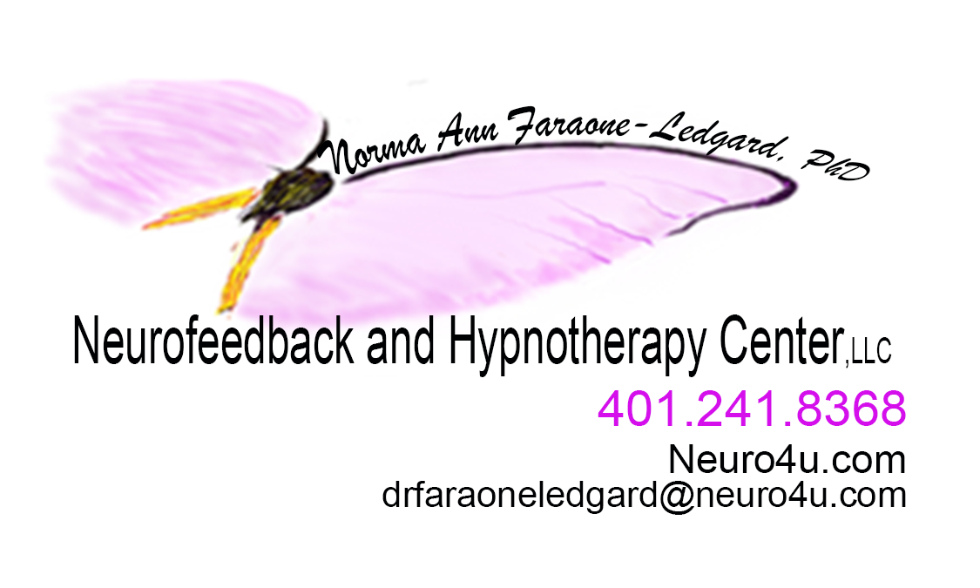

Date: _________________________________
Name: ____________________________________________________________________________________
Street Address:
City: __________________________________________ State: RI _________________ Zip Code:
Date of Birth: Age: Sex: F M

Telephone numbers:
Home:
Work: ________________________________________________________
Email:
Pager: ________________________________________________________
Cell phone:
Person to contact in case of emergency Telephone number

Employment Information:
Place of Business: ____________________________________________________________________
Address: ___________________________________________________________________________
Current Occupation: ___________________________________________________________________
Education Information:
Education: | 1,2,3,4,5,6,7,8, | _____Elementary/Jr. High School
(circle highest | 9,10,11,12 | _____High School
grade) | 13,14, | _____Associates Degree (in what_______________)
 | 15,1617,18, | _____Bachelors (in what______________________)
 | 19,20 | _____Masters Degree (in what_________________)
 | 20+ | _____Post Grad (in what______________________)

Certificate Program ( in what/_____ __________________________________)

Family Information:
Marital Status: married _______________________________________________________________________ Name of spouse/significant other: __________________________________________________________ Date of birth Spouse/Significant other______________________________________________________ Age of Spouse/Significant other____________________________________________________________ Years Married/living together: _____________________________________________________________
Children # of: _____ Names and ages of children: ___________________________________________
___________________________________________
Other Household Members: Names, ages, relationships
__________________________________ _________________________________________:
_____________________________ ___________________________________

Religious Background: _________________________________________________________
From whom did you hear about Neurofeedback and Hypnotherapy Center LLC?
__________________________________________________________________________

Chief Complaint:
Briefly describe the problem(s) for which you are seeking treatment, including the severity and how long you have had this (these) problem(s). ________________________________________________________
_______________________________________________________________________________________
______________________________________________________________________________________

Therapy History:
Whom have you consulted for this problem: (e.g. MD, Friend, etc)
Provide name and relationship: ___________________________________________________________
_________________________________________________________________________

Give a brief description of how you think Neurofeedback and Hypnotherapy Center LLC, can help you and what type of treatment you are expecting (e.g. individual psychotherapy, clinical hypnosis, biofeedback, art therapy)
__________________________________________________________________________

Have you ever been in therapy before? Yes_____ No _____
Name of person ________________________________________________________________________
Address ______________________________________________________________________________
Telephone Number______________________________________________________________________
How long were you with this person? _______________________________________________________
What diagnosis were you given? __________________________________________
HIPPA Compliance: I give Neurofeedback and Hypnotherapy Center, LLC, permission to contact all providers necessary to provide continuity of care. Consent to outreach for prior treatment information? Yes_____ No_____

Medical Professional taking care of you:
Name of current medical doctor PCP? ________________________________________________________
Address:_______________________________________________________________________________ Telephone number:______________________________________________________________________
Name, address, and telephone number of any other providers you are seeking for treatment and for what?

Are you currently taking any medication (Rx or OTC)? Please list name, dosage and frequency?
1.
2. Many others ____________________________________________________________________________________ 3.____________________________________________________________________________________ 4.____________________________________________________________________________________ 5.____________________________________________________________________________________ 6.____________________________________________________________________________________
What medications have you taken in the last two years and are no longer taking?
1.____________________________________________________________________________________
2.____________________________________________________________________________________
3.____________________________________________________________________________________
Have you ever stopped taking a medication that was prescribed to you without your doctor knowing?
If yes what was that medication:___________________________________________________________
List allergies to medications/ food/, etc. that you have: __________________________________________

_________________________________________________________________________

Agreement of Consent for Treatment
___________________________________________. Date:_____________________ Signature on file
Agreement of Consent for Hypnotherapy Treatment Signature on file
_________________________________________________ Date_________________________ Patient’s name or responsible person
Agreement of Consent for Neurofeedback and/or Biofeedback Treatment Signature on file
_________________________________________________ Date_________________________ Patient’s name or responsible person
Agreement of Consent to contact other necessary providers who have or are currently treating you. Signature on file
________________________________________________ Date_________________________ Patient’s name or responsible person
COURT CASES/ Workman Comp Cases: This office respectfully declines all of these cases.

Neurofeedback and Hypnotherapy Center, LLC.’s philosophy is that since it is a solo practice so on a case by case basis it will only be considered. You will be responsible for ALL cost associated to your case.

________________________________________________ Date_________________________ Patient’s name or responsible person
NOTE TAKING

Neurofeedback and Hypnotherapy Center, LLC.’s philosophy due to confidentiality issues will write what is necessary to provide care. Should you need a written summary of any kind this will only be permissible upon your written consent with at least a three-week advanced notification. Neurofeedback and Hypnotherapy Center LLC reserves the right to what is felt necessary to provide care and information to other providers.
Signature on file

________________________________________________ Date_________________________ Patient’s name or responsible person
MISSED APPOINTMENTS/BILLED SERVICES
Unless cancelled at least 24 hours in advance Neurofeedback and Hypnotherapy Center, LLC’s policy is to charge for missed appointments at the rate of a standard office visit. Keeping your appointment is considered part of your treatment plan.
________________________________________________ Date_________________________ Patient’s name or responsible person
EMERGENCY SITUATIONS
The office is reachable by telephone at all times, 24 hours a day, seven days a week. You can leave a message on the voice mail anytime and expect a return call within 48 business hours. In cases of an emergency, simply state that it is an emergency in the message and a return call will be made as soon as possible. However, IF YOU CAN NOT WAIT please seek attention by calling 911, your PCP, or by going to your nearest emergency treatment facility. Should Neurofeedback and Hypnotherapy Center LLC be closed (ex. Vacation or Sick Leave)… You will be notified one week in advance for a vacation leave and as soon as possible if sick leave is necessary. Signature on file
________________________________________________ Date_________________________ Patient’s name or responsible person
LEGAL SITUATIONS

I understand that my records are protected under the state law governing health care information that relates to mental health services and they cannot be disclosed without my written consent unless otherwise provided for in state or federal regulations.
I understand that you are legally responsible to report any findings of child or elderly abuse, homicidal or suicidal actions caused by the patient to the appropriate authorities.
Signature on file
________________________________________________ Date_________________________ Patient’s name or responsible person
Treatment Goals: List what you want out of treatment from Neurofeedback and Hypnotherapy Center LLC
Goal one: _____________________________________________________________________
Goal two: _____________________________________________________________________

Goal three: ___________________________________________________________________

Hobbies: List three hobbies you enjoy.

Hobby one: ___________________________________________________________________

Hobby two: ___________________________________________________________________

Hobby three: __________________________________________________________________

Strengths and Weakness: List three strengths you feel you possess as well as three weakness.

Strength one: _________________________________________________________________
Strength two: _________________________________________________________________

Strength three: ________________________________________________________________

Weakness one: ________________________________________________________________
Weakness two: ________________________________________________________________

Weakness three: ______________________________________________________________

Opportunity to provide any other information you want Neurofeedback and Hypnotherapy Center, LLC. to know:

Payment Schedule:
Please refer to Website as well for special and options of services
Please sign your payment agreement

Hypnotherapy: 1 hour - $200.00 Agreement _________________________________
Hypnotherapy: ½ hour - $100.00 Agreement _________________________________

Neurofeedback (full package 40 sessions)_ $3,000.00 Agreement ____________________
Neurofeedback other packages to be discussed # of sessions __________@$___________ session Agreement___________________________________________________

Biofeedback: packages to be discussed # of session ___________$ number of session ______
Agreement_________________________________

Psychotherapy: 1 hour - $100.00 Agreement _________________________________
Couples Therapy: 1 Hour - $200.00 Agreement _________________________________
Family Therapy: 1 Hour - $200.00 Agreement _________________________________
Home Visits ( to be determined by hour and distance)
Hospital visits/ Nursing Home visits (to be determined by hour and distance)_
Telehealth – depending upon services and length of time @ $50.00 to $200.00

